# Testing Lab 1: Your First Component Test

## Objectives

*  Install React Testing Library
*  Create Your First Component Test

## Steps

This lab is designed to start with the code after finishing:

**Lab 25: Redux with React**

### Install React Testing Library

1. Open a command prompt (Windows) or terminal (Mac).
2. Change the **current directory** to keeptrack.
3. **Run** the following command to run the test:

#### npm

npm test

1. Press a to run all tests.
2. Verify the test created by Create React App fails.

FAIL src/App.test.js

Unable to find an element with the text: /learn react/i.

1. Open the file src/App.test.js
2. Update the test code.

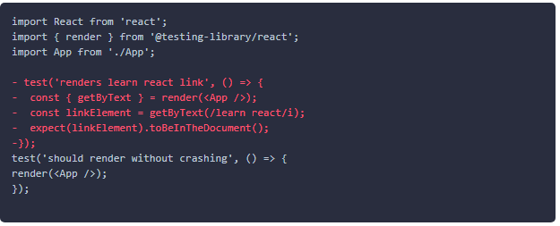

Note: We will test the the content (as the generated test was) in a HomePage component test in the next step.

1. Verify the test now passes.

PASS src/App.test.js

**Create Your First Component Test**

1. Create the file src\home\HomePage.test.js.
2. Add a test to verify the component shallow renders without crashing.

#### src\home\HomePage.test.js

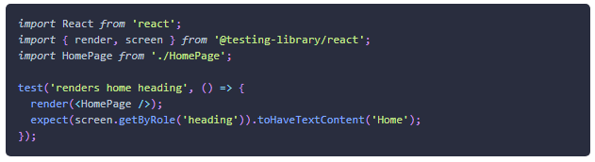

1. Verify the test passes.

PASS src/home/HomePage.test.js

### ✔ You have completed Testing Lab 1